
Engenharia de Computação
Laboratório de Redes de Computadores I
Aula Prática 14 – Pentest parte III
Nomes: Arthur Bracarense & Gustavo de Assis

1) Qual o endereço IP da máquina kali do seu computador?

172.22.0.232

└─# sudo ifconfig
eth0: flags=4163<UP,BROADCAST,RUNNING,MULTICAST> mtu 1500
inet 172.22.0.232 netmask 255.255.0.0 broadcast 172.22.255.255
inet6 fe80::7f6b:b1b9:4d64:8115 prefixlen 64 scopeid 0x20<link>
ether 08:00:27:3b:c5:1b txqueuelen 1000 (Ethernet)
RX packets 63204 bytes 86031595 (82.0 MiB)
RX errors 0 dropped 10 overruns 0 frame 0
TX packets 4550 bytes 713155 (696.4 KiB)
TX errors 0 dropped 0 overruns 0 carrier 0 collisions 0

lo: flags=73<UP,LOOPBACK,RUNNING> mtu 65536
inet 127.0.0.1 netmask 255.0.0.0
inet6 ::1 prefixlen 128 scopeid 0x10<host>
loop txqueuelen 1000 (Local Loopback)
RX packets 24 bytes 1240 (1.2 KiB)
RX errors 0 dropped 0 overruns 0 frame 0
TX packets 24 bytes 1240 (1.2 KiB)
TX errors 0 dropped 0 overruns 0 carrier 0 collisions 0

2) Pergunte o IP da máquina kali alvo (SERVIDOR) para a professora e teste a conectividade entre as máquinas, realizando um ping.
172.22.1.141 – Rede:172.22.1.0/24
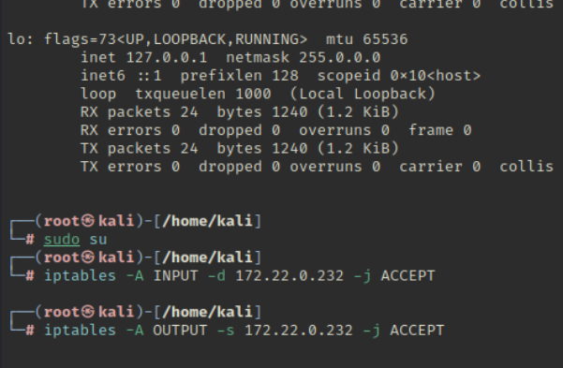
3) Se conseguiu a conexão entre as máquinas, a conexão está correta e podemos começar.
OK.
4) Vamos conhecer e usar a ferramenta nmap para obter informações de uma rede e/ou de algum alvo. Para isso, na máquina kali alvo estão sendo executados alguns serviços: web, FTP, SSH, SMTP, Samba, MariaDB, SNMP.
OK.
5) Vamos ativar o iptables para monitorar os pacotes de entrada e de saída do seu computador, com os seguintes comandos (coloque o IP do SEU kali nos comandos):
sudo su
iptables -A INPUT -d IP -j ACCEPT
iptables -A OUTPUT -s IP -j ACCEPT
iptables -nvL
OK.
6) A saída deve ser parecida com:
OK.
7) Podemos verificar os serviços e portas TCP (e/ou UDP) sendo utilizados na máquina do kali (servidor) por meio do comando nmap:
nmap -v -sT IP_SERVIDOR
nmap -v -sU -p 160-170 --max-retries 1 IP_SERVIDOR
(OBS: o nmap do UDP é mais lento)
┌──(root㉿kali)-[/home/kali]
└─# nmap -v -sT 172.22.1.141
Starting Nmap 7.95 ( https://nmap.org ) at 2025-01-31 05:54 EST
Initiating ARP Ping Scan at 05:54
Scanning 172.22.1.141 [1 port]
Completed ARP Ping Scan at 05:54, 0.04s elapsed (1 total hosts)
Initiating Parallel DNS resolution of 1 host. at 05:54
Completed Parallel DNS resolution of 1 host. at 05:54, 0.00s elapsed
Initiating Connect Scan at 05:54
Scanning 172.22.1.141 [1000 ports]
Discovered open port 80/tcp on 172.22.1.141
Discovered open port 22/tcp on 172.22.1.141
Discovered open port 25/tcp on 172.22.1.141
Discovered open port 21/tcp on 172.22.1.141
Discovered open port 445/tcp on 172.22.1.141
Discovered open port 139/tcp on 172.22.1.141
Completed Connect Scan at 05:54, 0.05s elapsed (1000 total ports)
Nmap scan report for 172.22.1.141
Host is up (0.00084s latency).
Not shown: 994 closed tcp ports (conn-refused)
PORT STATE SERVICE
21/tcp open ftp
22/tcp open ssh
25/tcp open smtp
80/tcp open http
139/tcp open netbios-ssn
445/tcp open microsoft-ds
MAC Address: 00:0C:29:C9:26:F7 (VMware)

Read data files from: /usr/share/nmap
Nmap done: 1 IP address (1 host up) scanned in 0.15 seconds
Raw packets sent: 1 (28B) | Rcvd: 1 (28B)

┌──(root㉿kali)-[/home/kali]
└─# nmap -v -sU -p 160-170 --max-retries 1 172.22.1.141
Starting Nmap 7.95 ( https://nmap.org ) at 2025-01-31 05:57 EST
Initiating ARP Ping Scan at 05:57
Scanning 172.22.1.141 [1 port]
Completed ARP Ping Scan at 05:57, 0.04s elapsed (1 total hosts)
Initiating Parallel DNS resolution of 1 host. at 05:57
Completed Parallel DNS resolution of 1 host. at 05:57, 0.00s elapsed
Initiating UDP Scan at 05:57
Scanning 172.22.1.141 [11 ports]
Warning: 172.22.1.141 giving up on port because retransmission cap hit (1).
Completed UDP Scan at 05:57, 1.30s elapsed (11 total ports)
Nmap scan report for 172.22.1.141
Host is up (0.0018s latency).

PORT STATE SERVICE
160/udp closed sgmp-traps
161/udp open|filtered snmp
162/udp closed snmptrap
163/udp closed cmip-man
164/udp open|filtered smip-agent
165/udp closed xns-courier
166/udp open|filtered s-net
167/udp closed namp
168/udp closed rsvd
169/udp closed send
170/udp open|filtered print-srv
MAC Address: 00:0C:29:C9:26:F7 (VMware)

Read data files from: /usr/share/nmap
Nmap done: 1 IP address (1 host up) scanned in 1.44 seconds
Raw packets sent: 19 (754B) | Rcvd: 8 (420B)

8) Deve aparecer algo parecido com:
OK.
9) No seu computador, veja o tráfego de pacotes gerados pelo nmap e recebidos/respondidos pelo kali alvo:
iptables -nvL

──(root㉿kali)-[/home/kali]
└─# iptables -nvL
Chain INPUT (policy ACCEPT 0 packets, 0 bytes)
pkts bytes target prot opt in out source destination
1013 41282 ACCEPT 0 -- * * 0.0.0.0/0 172.22.0.232

Chain FORWARD (policy ACCEPT 0 packets, 0 bytes)
pkts bytes target prot opt in out source destination

Chain OUTPUT (policy ACCEPT 0 packets, 0 bytes)
pkts bytes target prot opt in out source destination
1039 61946 ACCEPT 0 -- * * 172.22.0.232 0.0.0.0/0
10) Isso é só para mostrar que o nmap gera tráfego que pode deixar a rede lenta durante um pentest ou que pode ser detectado por um sistema de Intrusion Detection System (IDS), no caso de uma tentativa de invasão.
OK.
11) Para usar o nmap em uma rede toda, podemos executar o seguinte comando (coloque o IP da rede do servidor) e direcionar a resposta para um arquivo texto:
nmap -v -sn IP_REDE/24 -oG hostsvivos.txt

# Nmap 7.95 scan initiated Fri Jan 31 06:01:47 2025 as: /usr/lib/nmap/nmap -v -sn -oG hostsvivos.txt 172.22.1.0/24
# Ports scanned: TCP(0;) UDP(0;) SCTP(0;) PROTOCOLS(0;)

Host: 172.22.1.0 () Status: Up
Host: 172.22.1.1 () Status: Down
Host: 172.22.1.2 () Status: Down
Host: 172.22.1.3 () Status: Down
Host: 172.22.1.4 () Status: Down
Host: 172.22.1.5 () Status: Down
Host: 172.22.1.6 () Status: Down
Host: 172.22.1.7 () Status: Down
Host: 172.22.1.8 () Status: Down
Host: 172.22.1.9 () Status: Down
Host: 172.22.1.10 () Status: Down
Host: 172.22.1.11 () Status: Up
Host: 172.22.1.12 () Status: Down
Host: 172.22.1.13 () Status: Down
Host: 172.22.1.14 () Status: Down
Host: 172.22.1.15 () Status: Down
Host: 172.22.1.16 () Status: Down
Host: 172.22.1.17 () Status: Up
Host: 172.22.1.18 () Status: Down
Host: 172.22.1.19 () Status: Up
Host: 172.22.1.20 () Status: Down
Host: 172.22.1.21 () Status: Up
Host: 172.22.1.22 () Status: Down
…
Host: 172.22.1.33 () Status: Down
Host: 172.22.1.34 () Status: Up
Host: 172.22.1.35 () Status: Up
Host: 172.22.1.36 () Status: Down
Host: 172.22.1.37 () Status: Down
Host: 172.22.1.38 () Status: Down
Host: 172.22.1.39 () Status: Down
Host: 172.22.1.40 () Status: Down
Host: 172.22.1.41 () Status: Up
Host: 172.22.1.42 () Status: Down
Host: 172.22.1.43 () Status: Down
Host: 172.22.1.44 () Status: Down
Host: 172.22.1.45 () Status: Down
Host: 172.22.1.46 () Status: Down
Host: 172.22.1.47 () Status: Down
Host: 172.22.1.48 () Status: Up
Host: 172.22.1.49 () Status: Down
Host: 172.22.1.50 () Status: Down
Host: 172.22.1.51 () Status: Up
Host: 172.22.1.52 () Status: Down
Host: 172.22.1.53 () Status: Down
Host: 172.22.1.54 () Status: Down
Host: 172.22.1.55 () Status: Down
Host: 172.22.1.56 () Status: Down
Host: 172.22.1.57 () Status: Up
Host: 172.22.1.58 () Status: Down
Host: 172.22.1.59 () Status: Down
Host: 172.22.1.60 () Status: Down
Host: 172.22.1.61 () Status: Up
Host: 172.22.1.62 () Status: Down
Host: 172.22.1.63 () Status: Up
Host: 172.22.1.64 () Status: Up
Host: 172.22.1.65 () Status: Down
Host: 172.22.1.66 () Status: Down
Host: 172.22.1.67 () Status: Up
Host: 172.22.1.68 () Status: Down
Host: 172.22.1.69 () Status: Down
Host: 172.22.1.70 () Status: Down
Host: 172.22.1.71 () Status: Down
Host: 172.22.1.72 () Status: Down
Host: 172.22.1.73 () Status: Up
Host: 172.22.1.74 () Status: Down
Host: 172.22.1.75 () Status: Down
Host: 172.22.1.76 () Status: Down
Host: 172.22.1.77 () Status: Down
Host: 172.22.1.78 () Status: Down
Host: 172.22.1.79 () Status: Down
Host: 172.22.1.80 () Status: Down
Host: 172.22.1.81 () Status: Up
Host: 172.22.1.82 () Status: Down
Host: 172.22.1.83 () Status: Up
Host: 172.22.1.84 () Status: Down
Host: 172.22.1.85 () Status: Down
Host: 172.22.1.86 () Status: Up
Host: 172.22.1.87 () Status: Down
Host: 172.22.1.88 () Status: Down
Host: 172.22.1.89 () Status: Up
Host: 172.22.1.90 () Status: Down
…

Host: 172.22.1.99 () Status: Down
Host: 172.22.1.100 () Status: Up
Host: 172.22.1.101 () Status: Down
…
Host: 172.22.1.130 () Status: Down
Host: 172.22.1.131 () Status: Up
Host: 172.22.1.132 () Status: Down
Host: 172.22.1.133 () Status: Down
Host: 172.22.1.134 () Status: Up
Host: 172.22.1.135 () Status: Down
Host: 172.22.1.136 () Status: Down
Host: 172.22.1.137 () Status: Down
Host: 172.22.1.138 () Status: Down
Host: 172.22.1.139 () Status: Down
Host: 172.22.1.140 () Status: Up
Host: 172.22.1.141 () Status: Up
Host: 172.22.1.142 () Status: Down
…
Host: 172.22.1.184 () Status: Down
…
Host: 172.22.1.185 () Status: Down
Host: 172.22.1.186 () Status: Up
Host: 172.22.1.187 () Status: Down
…
# Nmap done at Fri Jan 31 06:01:49 2025 -- 256 IP addresses (26 hosts up) scanned in 1.80 seconds

12) Responda:
◦ O que você identifica no resultado do nmap na sua rede?
◦ Como estão informações podem ser úteis para um atacante?
Identifico que o nmap fez o scan e vários dispositivos foram identificados como ativo (up). Essa informação pode ser útil, pois o atacante pode centrar seus esforços nesses dispositivos.

13) Podemos usar o arquivo texto obtido para fazer um mapeamento apenas nas máquinas que estão ativas na rede e procurar por um serviço específico, por exemplo, web nas portas 80, 8080 e 443 ou por serviço, http:
grep "Up" hostsvivos.txt | cut -d " " -f2 > ips
nmap -v --open -sS -p 80,8080,443 -Pn -iL ips
nmap -v --open -sS -p http* -Pn -iL ips

┌──(root㉿kali)-[/home/kali]
└─# grep "Up" hostsvivos.txt | cut -d " " -f2 > ips

┌──(root㉿kali)-[/home/kali]
└─# nmap -v --open -sS -p 80,8080,443 -Pn -iL ips
Host discovery disabled (-Pn). All addresses will be marked 'up' and scan times may be slower.
Starting Nmap 7.95 ( https://nmap.org ) at 2025-01-31 06:06 EST
Initiating ARP Ping Scan at 06:06
Scanning 26 hosts [1 port/host]
Completed ARP Ping Scan at 06:06, 1.25s elapsed (26 total hosts)
Initiating Parallel DNS resolution of 25 hosts. at 06:06
Completed Parallel DNS resolution of 25 hosts. at 06:06, 0.00s elapsed
Initiating SYN Stealth Scan at 06:06
Scanning 25 hosts [3 ports/host]
Discovered open port 80/tcp on 172.22.1.21
Discovered open port 80/tcp on 172.22.1.34
Discovered open port 80/tcp on 172.22.1.17
Discovered open port 80/tcp on 172.22.1.100
Discovered open port 80/tcp on 172.22.1.83
Discovered open port 80/tcp on 172.22.1.51
Discovered open port 80/tcp on 172.22.1.89
Discovered open port 80/tcp on 172.22.1.41
Discovered open port 8080/tcp on 172.22.1.19
Discovered open port 80/tcp on 172.22.1.11
Discovered open port 80/tcp on 172.22.1.140
Discovered open port 80/tcp on 172.22.1.134
Discovered open port 80/tcp on 172.22.1.131
Discovered open port 80/tcp on 172.22.1.141
Completed SYN Stealth Scan at 06:06, 1.23s elapsed (75 total ports)
Nmap scan report for 172.22.1.11
Host is up (0.00034s latency).
Not shown: 2 closed tcp ports (reset)
PORT STATE SERVICE
80/tcp open http
MAC Address: 9C:6B:00:28:CD:C0 (ASRock Incorporation)

Nmap scan report for 172.22.1.17
Host is up (0.00079s latency).
Not shown: 2 filtered tcp ports (no-response)
Some closed ports may be reported as filtered due to --defeat-rst-ratelimit
PORT STATE SERVICE
80/tcp open http
MAC Address: D0:94:66:DB:39:74 (Dell)

Nmap scan report for 172.22.1.19
Host is up (0.00043s latency).
Not shown: 2 closed tcp ports (reset)
PORT STATE SERVICE
8080/tcp open http-proxy
MAC Address: 34:64:A9:02:BD:BC (Hewlett Packard)

…

Nmap scan report for 172.22.1.141
Host is up (0.0018s latency).
Not shown: 2 closed tcp ports (reset)
PORT STATE SERVICE
80/tcp open http
MAC Address: 00:0C:29:C9:26:F7 (VMware)

Read data files from: /usr/share/nmap
Nmap done: 26 IP addresses (25 hosts up) scanned in 2.58 seconds
Raw packets sent: 139 (5.668KB) | Rcvd: 67 (2.400KB)

┌──(root㉿kali)-[/home/kali]
└─# nmap -v --open -sS -p http* -Pn -iL ips
Host discovery disabled (-Pn). All addresses will be marked 'up' and scan times may be slower.
Starting Nmap 7.95 ( https://nmap.org ) at 2025-01-31 06:06 EST
Initiating ARP Ping Scan at 06:06
Scanning 26 hosts [1 port/host]
Completed ARP Ping Scan at 06:06, 1.25s elapsed (26 total hosts)
Initiating Parallel DNS resolution of 25 hosts. at 06:06
Completed Parallel DNS resolution of 25 hosts. at 06:06, 0.00s elapsed
Initiating SYN Stealth Scan at 06:06
Scanning 25 hosts [12 ports/host]
Discovered open port 8080/tcp on 172.22.1.19
Discovered open port 80/tcp on 172.22.1.34
Discovered open port 80/tcp on 172.22.1.21
Discovered open port 80/tcp on 172.22.1.17
Discovered open port 80/tcp on 172.22.1.83
Discovered open port 80/tcp on 172.22.1.100
Discovered open port 80/tcp on 172.22.1.51
Discovered open port 80/tcp on 172.22.1.89
Discovered open port 80/tcp on 172.22.1.41
Discovered open port 80/tcp on 172.22.1.11
Discovered open port 80/tcp on 172.22.1.140
Discovered open port 80/tcp on 172.22.1.134
Discovered open port 80/tcp on 172.22.1.141
Discovered open port 80/tcp on 172.22.1.131
Completed SYN Stealth Scan at 06:06, 1.52s elapsed (300 total ports)
Nmap scan report for 172.22.1.11
Host is up (0.00040s latency).
Not shown: 11 closed tcp ports (reset)
PORT STATE SERVICE
80/tcp open http
MAC Address: 9C:6B:00:28:CD:C0 (ASRock Incorporation)

Nmap scan report for 172.22.1.17
Host is up (0.00073s latency).
Not shown: 11 filtered tcp ports (no-response)
Some closed ports may be reported as filtered due to --defeat-rst-ratelimit
PORT STATE SERVICE
80/tcp open http
MAC Address: D0:94:66:DB:39:74 (Dell)

…

Nmap scan report for 172.22.1.134
Host is up (0.00039s latency).
Not shown: 11 filtered tcp ports (no-response)
Some closed ports may be reported as filtered due to --defeat-rst-ratelimit
PORT STATE SERVICE
80/tcp open http
MAC Address: D0:94:66:DB:3A:60 (Dell)

Nmap scan report for 172.22.1.141
Host is up (0.0012s latency).
Not shown: 11 closed tcp ports (reset)
PORT STATE SERVICE
80/tcp open http
MAC Address: 00:0C:29:C9:26:F7 (VMware)

Read data files from: /usr/share/nmap
Nmap done: 26 IP addresses (25 hosts up) scanned in 2.88 seconds
Raw packets sent: 496 (21.376KB) | Rcvd: 172 (6.624KB)

14) O retorno mostra quais dispositivos estão com o serviço web ativo, nas portas indicadas. Há servidores web na rede?
Sim. Como visto em Discovered open port 80/tcp on 172.22.1.100…

15) O nmap possui inúmeros parâmetros de pesquisa e uma outra opção é mapear pelas portas dos serviços mais usados. O comando a seguir mapeia com as 5 portas mais usadas (pode ser qualquer número):
nmap -v --open -sS --top-ports=5 -Pn -iL ips
NOT OK.

16) Quais são os 5 serviços que aparecem na rede?
┌──(root㉿kali)-[/home/kali]
└─# >....

Nmap scan report for 172.22.1.131
Host is up (0.00071s latency).
Not shown: 11 filtered tcp ports (no-response)
Some closed ports may be reported as filtered due to --defeat-rst-ratelimit
PORT STATE SERVICE
80/tcp open http
MAC Address: D0:94:66:DB:52:0F (Dell)

Nmap scan report for 172.22.1.134
Host is up (0.00039s latency).
Not shown: 11 filtered tcp ports (no-response)
Some closed ports may be reported as filtered due to --defeat-rst-ratelimit
PORT STATE SERVICE
80/tcp open http
MAC Address: D0:94:66:DB:3A:60 (Dell)

Nmap scan report for 172.22.1.140
Host is up (0.00055s latency).
Not shown: 11 filtered tcp ports (no-response)
Some closed ports may be reported as filtered due to --defeat-rst-ratelimit
PORT STATE SERVICE
80/tcp open http
MAC Address: 9C:6B:00:28:C8:D3 (ASRock Incorporation)

Nmap scan report for 172.22.1.141
Host is up (0.0012s latency).
Not shown: 11 closed tcp ports (reset)
PORT STATE SERVICE
80/tcp open http
MAC Address: 00:0C:29:C9:26:F7 (VMware)

RCLEARead data files from: /usr/share/nmap
Nmap done: 26 IP addresses (25 hosts up) scanned in 2.88 seconds
Raw packets sent: 496 (21.376KB) | Rcvd: 172 (6.624KB)

PS: Acredito que não seja a resposta esperada, dessa forma, fazendo um pesquisa complementar, acredito que a resposta esperada fosse algo como:
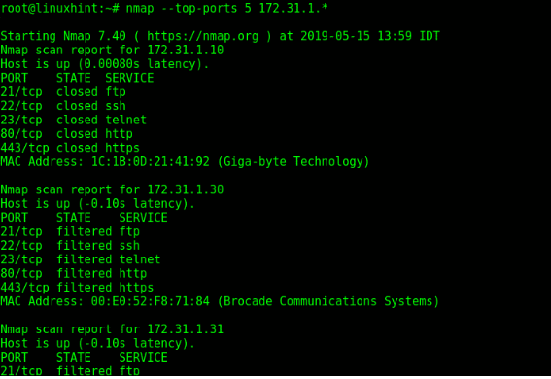
Site:
https://linuxhint.com/nmap_network_scanning/
Que nesse caso seriam portas 21 tcp, 22 ssh, 80 http, entre outras mais utilizadas.

17) Para saber mais detalhes desses serviços como versão, sistema operacional, equipamento etc., pode-se usar o comando (o V de -sV indica version):
nmap -v --open -sV --top-ports=5 -Pn -iL ips
NOT OK. Mesma situação de antes. Vou complementar a resposta então.

18) Quais informações significativas você encontrou nos resultados desse comando?
Segundo o site, temos que:
Trecho anterior: “[...]Nmap tries to determine the service protocol (e.g. FTP, SSH, Telnet, HTTP), the application name (e.g. ISC BIND, Apache httpd, Solaris telnetd), the version number, hostname, device type (e.g. printer, router), the OS family (e.g. Windows, Linux).”

-sV (Version detection)
Enables version detection, as discussed above. Alternatively, you can use -A, which enables version detection among other things.
https://nmap.org/book/man-version-detection.html

Dessa forma, teríamos detalhes sobre o protocolo, a aplicação e sobre o SO (os que geralmente são obtidos).

19) Retorne o firewall para estado inicial:
sudo iptables -F
sudo iptables -X
sudo iptables -P INPUT ACCEPT
sudo iptables -P OUTPUT ACCEPT
sudo iptables -L

20) Agora vamos verificar um ataque do homem do meio (Man in The Middle ou MITM). Execute os seguintes comandos para instalar ferramentas para captura de tráfego:
sudo su
apt update
apt install dsniff
apt install driftnet

21) Execute o seguinte comando para o MITM encaminhar tráfego entre os dispositivos monitorados:
sysctl -w net.ipv4.ip_forward=1

22) Descubra o IP de outro computador da sua rede. Este outro PC gerará tráfego para o servidor para ser monitorado pelo MITM.

23) Digite os seguintes comandos (coloque os IPs correspondentes), UM EM CADA TERMINAL, NÃO FECHE OS TERMINAIS:
sudo arpspoof -i eth0 -t IP_SERVIDOR IP_outro_PC
sudo arpspoof -i eth0 -t IP_outro_PC IP_SERVIDOR
sudo dsniff -i eth0
sudo driftnet -i eth0
sudo urlsnarf -i eth0
(OBS: as terminais do dsniff e urlsnarf precisam estar visíveis e a janela do drifnet precisa ser aumentada)

24) No outro computador, gere tráfego de rede SEM CRIPTOGRAFIA (HTTP, FTP, etc.), por
exemplo:
1. Tente acessar o serviço FTP do Kali (troque IP pelo IP do servidor FTP indicado pela
professora):
ftp IP_SERVIDOR
(usuário e senha kali)
quit (para sair do FTP)
2. Execute o comando: wget http://IP_SERVIDOR (se estiver FORA da rede do CEFET, utilize o endereço http://scalmon.ddns.net:9000)
3. Abra um browser e acesse a página:
http://IP_SERVIDOR/teste_imagem.html (se estiver FORA da rede do CEFET, utilize o endereço http://scalmon.ddns.net:9000/teste_imagem.html)

25) Observe as informações capturadas e descreva o que ocorreu.

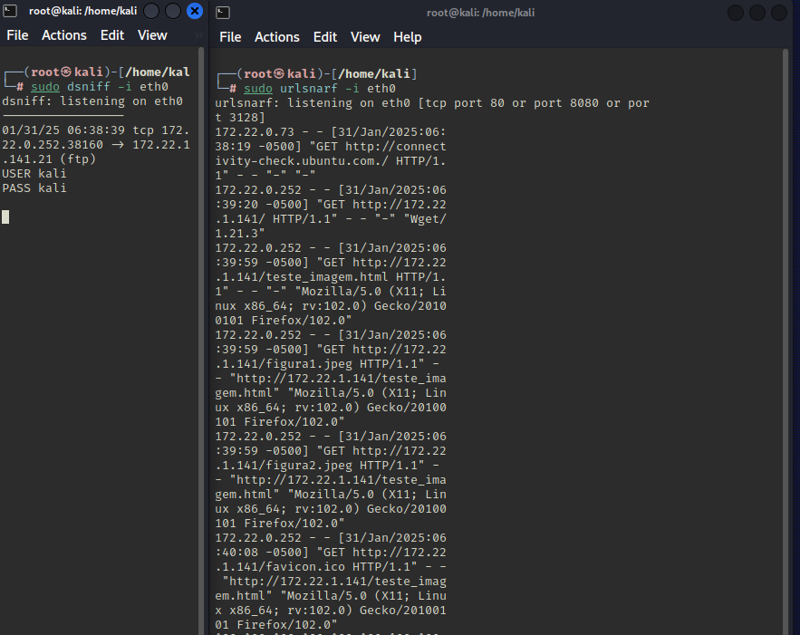
Temos que um login em FTP foi interceptado, como podemos ver no terminal à esquerda, onde vemos o usuário e o login do alvo.

26) Esse ataque MITM só captura tráfego sem criptografia, então tráfego com SSL/TLS não
será capturado. Entretanto, há ferramentas para fazer isso, como o proxy MITM. Fica aí
o desafio!

27) Envie suas respostas em PDF pelo SIGAA.
28) Para quem tem interesse em aprender mais sobre pentest, pesquise sobre os seguintes
temas:
◦ Enumeração
◦ Análise de vulnerabilidades
◦ Buffer overflow
◦ Exploits
◦ Ataques a senhas
◦ Web hacking
◦ Wi-Fi hacking
◦ Engenharia social

